Simple Verbal Predicate

✅ What Is a Simple Verbal Predicate?
# Source: AI Source: Provided by: [Data Path: Persons Table -> ID Column: 1, Name_En Column: Motasem Essam] -> From: [ChatGPT] on [8/4/2025]
A Simple Verbal Predicate is a single main verb or verb phrase that shows the action or state of the subject without any modifiers, complements, or additional phrases.
It is essentially the same as a simple predicate when the predicate is verbal (not nominal).

🔸 Key Features:
# Source: AI Source: Provided by: [Data Path: Persons Table -> ID Column: 1, Name_En Column: Motasem Essam] -> From: [ChatGPT] on [8/4/2025]
- Contains only the verb or main verb phrase.
- Does not include objects, adverbs, or modifiers.
- Built around an action verb or a linking verb.
- Can be simple tense or compound tense (with auxiliaries or modals).

🔸 Examples:
# Source: AI Source: Provided by: [Data Path: Persons Table -> ID Column: 1, Name_En Column: Motasem Essam] -> From: [ChatGPT] on [8/4/2025]
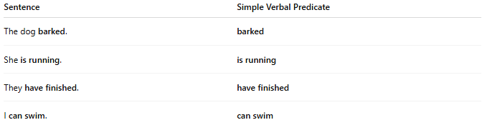
Sentence | Simple Verbal Predicate
The dog barked. | barked
She is running. | is running
They have finished. | have finished
I can swim. | can swim
✅ These examples show only the verb/verb phrase, without additional info like objects, adverbs, or prepositional phrases.

🔸 Compare With Complete Predicate:
# Source: AI Source: Provided by: [Data Path: Persons Table -> ID Column: 1, Name_En Column: Motasem Essam] -> From: [ChatGPT] on [8/4/2025]
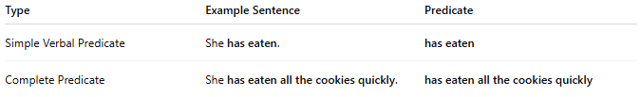
Type | Example Sentence | Predicate
Simple Verbal Predicate | She has eaten. | has eaten
Complete Predicate | She has eaten all the cookies quickly. | has eaten all the cookies quickly

